

**Name:** Abdul Ghani Khan

**Roll No:** 22P-9037

**Section:** BCS-3D

**Course:** Computer Organization & Assembly Language

**Assignment:** 01

**Question No. 1:**

**Write a program in assembly language for each of the below separately that sets**

**the following flags.**

**(Write four programs i.e. One for each part)**

**A) Zero Flag**

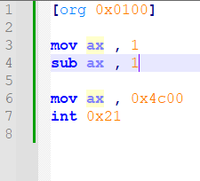***Code***

*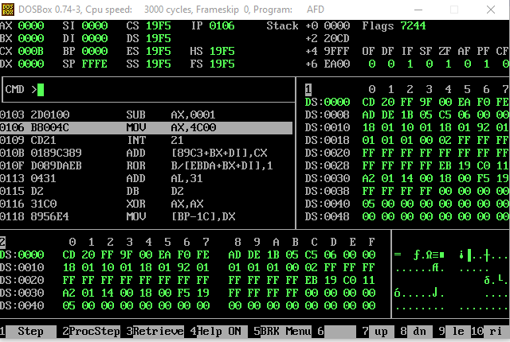****Result***

**B) Carry Flag**

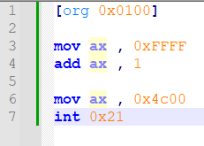***Code***

***Result***

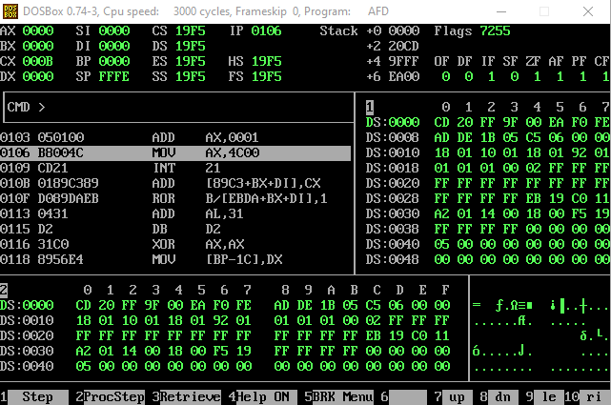

**C) Parity Flag**

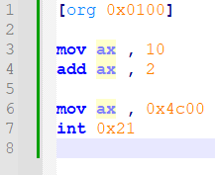***Code***

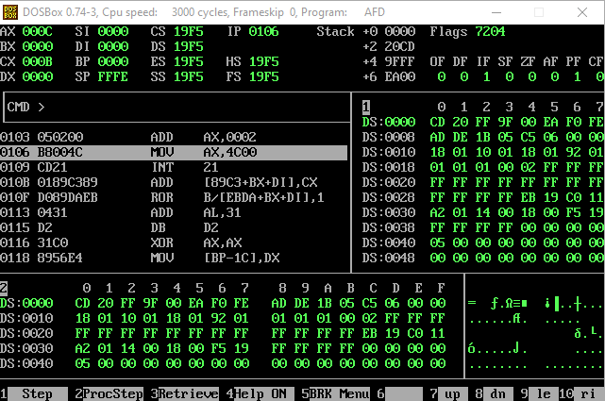***Result***

**D) Auxiliary Flag**

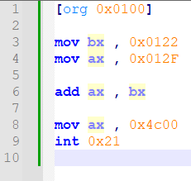***Code***

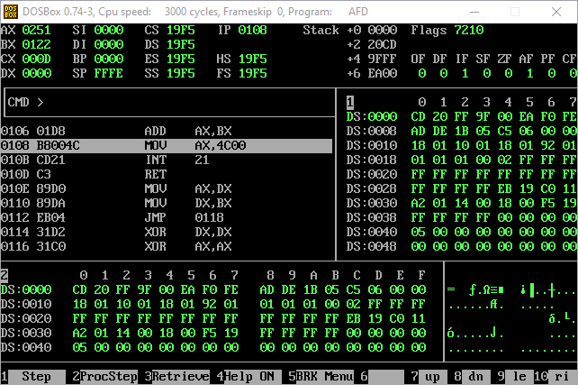***Result***

**Question No. 2:**

**What will be the size of the following assembly language program in bytes?**

**Explain your answer using “. lst” file of this code.**

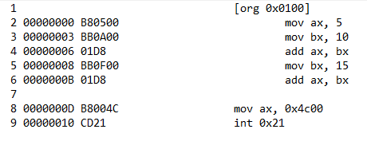

***Explanation: -***

Let’s Break down one by one as we know that the mov instruction takes 3 bytes and its used four times so 3 * 4 is 12. Also, we know that the add instruction takes 2 bytes and it is used twice so 2 * 2 is 4 so 12 + 4 is 16. Now the last instruction (int 0x21) takes 2 bytes Now adding them 16 + 2 = 18 so this program takes 18 bytes

Line By Line If We Add: 3 + 3 + 2 + 3 + 2 + 3 + 2 = 18

Also looking at the lst file our answer matches by counting the number of bytes each line of the instructions is taking.

**Question No. 3:**

**Calculate the physical memory address generated by the following segment-**

**offset pairs:**

**A. 1DDD:0436**

Physical Address:  **1E206**

**B. 1234:7920**

Physical Address: **19C60**

**C. 74F0:2123**

Physical Address: **77023**

**D. 0000:6727**

Physical Address:  **06727**

**E. FFFF:4336**

Physical Address: **04326**

**F. 1080:0100**

Physical Address: **10900**

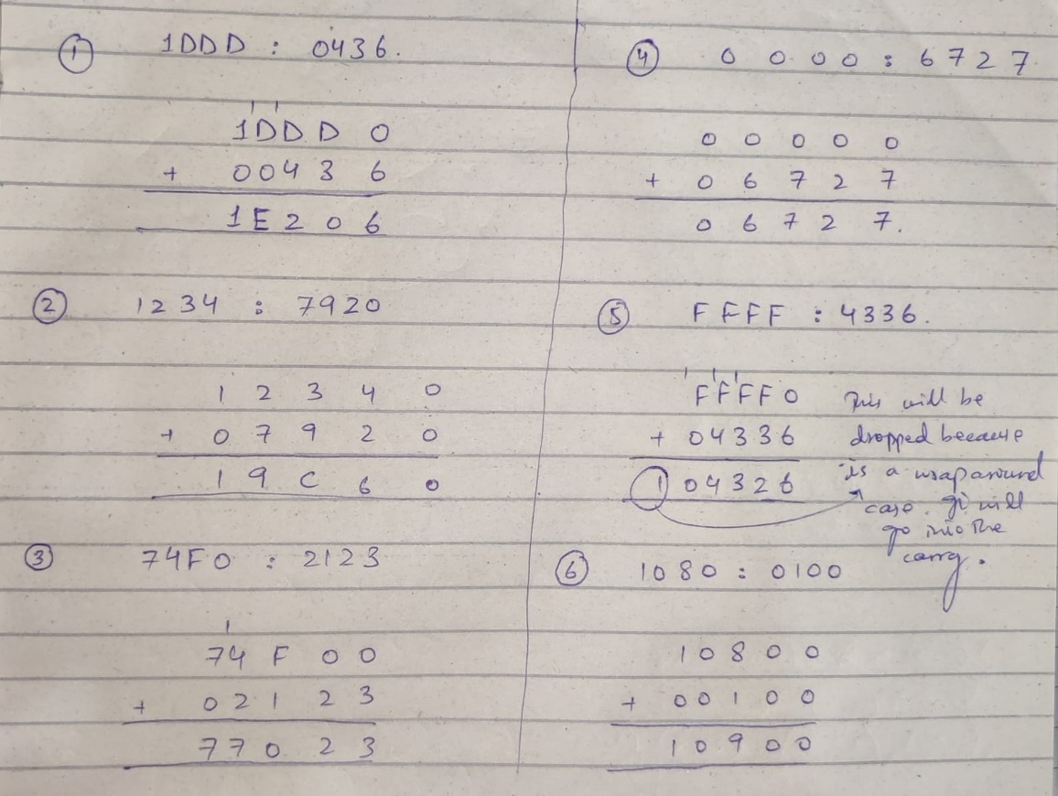**Rough Work**